Easy part:

- A massless spring is compressed between blocks of mass 5M and M on a smooth horizontal table. When the system is released, the energy of the spring is shared between the blocks such that:
(A) The mass M gets 5/6 of the energy
(B) The mass M gets 4/5 of the energy
(C) The mass M gets 1/2 of the energy
(D) The mass M gets 1/5 of the energy
(E) The mass M gets 1/6 of the energy

- A simple pendulum located beside you consists of a light string of length “ L” and a small but heavy bob of mass “M”. If the bob is released from rest when the string is horizontal and swings freely, the tension in the string when it is first vertical is given by :
(A) Mg (B) MgL (C) 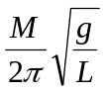 (D) 2Mg (E) 3Mg
- A space traveller has landed on the surface of and unknown planet rather similar to earth. He drops a small lead ball from the top of his spaceship and finds it takes 3.0 seconds to reach the ground, 18 meters below. If the astronaut weights 160 pounds on earth, how much does he weigh here, in pounds? Use any approximations you would see on earth.
(A) 0 (B) 32 (C) 192 (D) 4000 (E) 64

Medium part:

- Joe Carter hit a fly ball during spring training. It just cleared a 10 m high vertical fence on the way down at 45° as shown and struck the level ground 8 m beyond the fence. Calculate the speed of the ball when it left his bat at ground level. Of course we ignore air resistance. Answers in m/s.
(A) 22.6 (B) 19.7 (C) 24.1 (D) 20.8 (E) 18.6
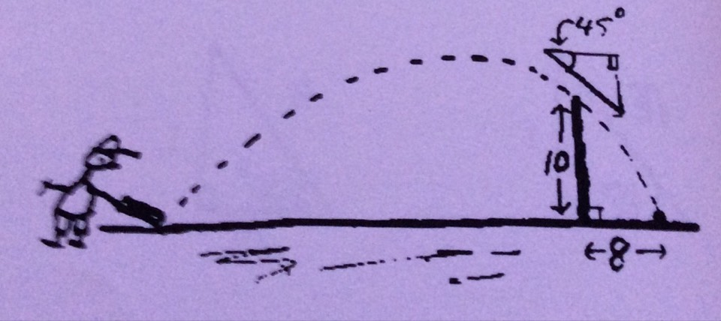

- Little Willie dreams of glory; “Lympic winner” - what a story! At the ski-jump, spectators roared; he overshoots, lands in a fjord!... A.A.
If Willie later makes a more modest jump on the hill shown here, find the distance L of his landing point in therm so H and θ. Neglect all frictional effects - ground and air (in a dream, all things are possible!). Use your expression to estimate L if H = 25 and θ = 36.9°. Answers in m.
(A) 80 n (B) 90 (C) 100 (D) 110 (E) 120
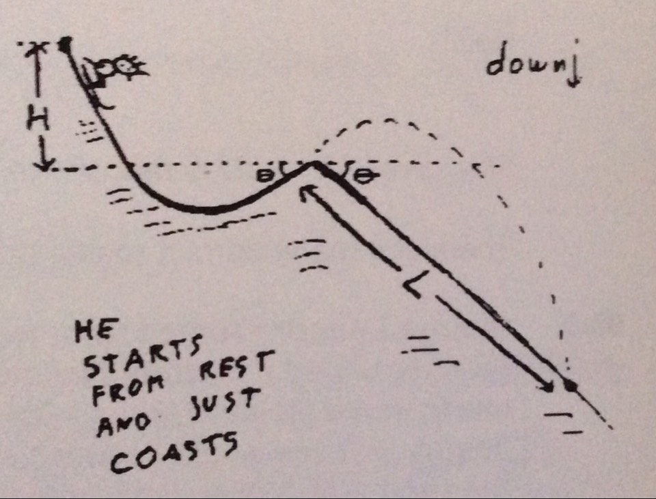

- Two Olympic figure skaters, Tonya HARD-FLING and Nancy CARE-AGAIN, collided in mid-air during practice. Their knee-jerk reaction was to hold onto each other so that immediately after impact they continued their motion in mid-air with a common velocity, having no rotation. Both skaters were travelling horizontally above the ice immediately before impact. Tonya of mass 45 kg, was moving due North at a speed of 21m/s. Nancy, of mass 55 kg, was moving 30° South of East at a speed of 14 m/s. Calculate the percentage of total kinetic energy lost by the pair during the collision.
(A) 75% (B) 67% (C) 50% (D) 33% (E) 4%

Hard part:
- Captain Quirk is lost in space with zero gravitational field. His massive space platform is a uniform flat wheel of diameter ten m which rotates about its axle at a constant rate of two revolutions per second. A light ideal spring of unstretched length two m is fastened to a point on the rim and stretches outward to maintain an instrument of mass three kg in a circular orbit in the plane of the wheel. If the spring constant is eight hundred N/m, calculate the total length of the stretched spring. Answers in m.
(A) 17.2 (B) 21.6 (C) 28.3 (D) 9.8 (E) 12.2

- Sadman Whatsizname flees across the flat desert in an armoured vehicle at 72 km/hr pursued by Storman Norman. He drives of the edge of a cliff 490 m above a lake of burning oil. Each time he strikes the surface of the lake, he bounces in a peculiar fashion. His horizontal velocity is unchanged, but his vertical velocity instantly reverses direction and decreases in magnitude by exactly 20 percent. What is the maximum width of the lake if Sadman is able to cheat the flames and reach the far shore?(Answer in m.)
(A) 800 (B) 1000 (C) 1800 (D) 2000 (E) there is no limit

